**Trabajo de Ingles-Escuela PrivadaTaragüi**

**Actividades de Ingles**

**5to año**

**Contenidos a trabajar: Presente Simple / Adverbios de Frecuencia / Reading** “**Eco-Friendly Cars”**

**Entrega del trabajo hasta el 3 de abril (a más tardar)**

* Les dejo en esta primera hoja un resumen de la teoría del Presente Simple y los Adverbios de Frecuencia para que vuelvan a repasar este tema.
* En la siguiente hoja tienen tres ejercicios del presente simple, luego otros tres de los adverbios para practicar estas teorías.
* Luego tienen un texto para leer y unir las oraciones.
* La última actividad es un escrito que lo van a hacer sobre la pregunta del punto dos explicando sus razones, deben escribir entre 100 - 150 palabras.
* Por cualquier consulta recuerden que en la página de la escuela esta mi correo
* Dejo también un código para la aplicación ***Google Classroom***, así también si tienen dudas o consultas me comunican por ese medio: **dn3pbj6**

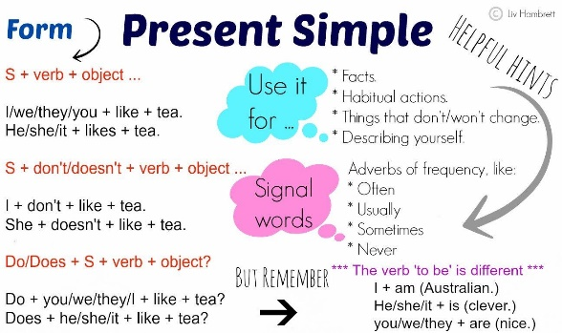

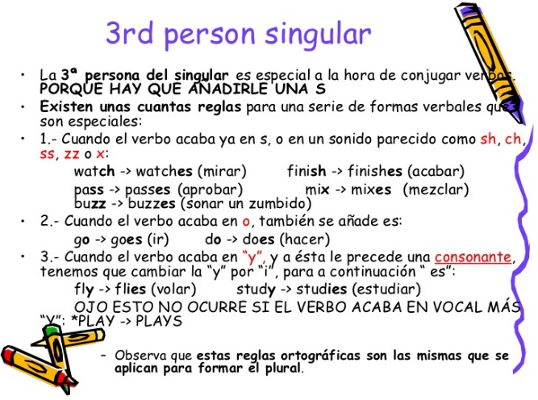

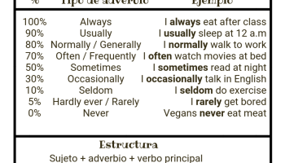

**Grammar: Present Simple**

**1.Read and complete the sentences using the verbs in brackets in the Simple Present**

1. My best friend ______**_*live***______(+, *live*) in Pittsburgh. He_____________________ (+, *love*) baseball.

2. He _____________(+, *wear*) his blue baseball cap every day. We like the same team!

3. We _______________(+, *play*) football together in the afternoons. We love sports!

4. Erick_______________________ (–, *criticise*) me. He listens to my problems.

5. We__________________ (–, *argue*) either. We are great friends!

6. I sometimes_________________ (+, *get*) jealous of Erick because he’s good at everything!

7. But then I___________________ (+, *remember*) that I am lucky to be his friend!

**2.Write questions using *Do* and *Does*.**

1. like / you / history / ? ***Do you like history?***

2. like / you / chemistry / ? _________________

3. use / you / an / eraser / ? _________________

4. your / family / listen / to / you / ? _________________

5. have / your / mum / breakfast / ? _________________

6. you / ever / forget / your / homework / ? _________________

**3.Complete the sentences with the negative (–) form of the verbs in brackets.**

1. My sister ____***Doesn´t like***__________(*like*) fish.

2. I _____________(*study*) on Fridays.

3. My teacher ______________(*tell*) jokes in class.

4. You ________________(*participate*) in class often!

5. We _________________(*go*) to the gym at weekends.

6. My dad _______________(*wear*) glasses.

**Grammar: Adverbs of Frequency**

1.**Read and complete the sentences with the following words.**

*usually / always / often / sometimes / never*

1. I _________ see my grandparents. Maybe twice a year.

2. We ___________ play volleyball after school. We play almost every day, but today we’re watching a film.

3. My cousin hates apples, so he_____________ eats them.

4. My school is______________ closed on Sunday.

5. My friends ____________ go to the cinema. They go once a week.

**2.Rewrite these sentences putting the adverbs in brackets in the right place.**

1 She gets up early on Sunday mornings. (sometimes) ___________________________

2 The boys have lunch together. (always) ___________________________

3 My father goes to work by car. (often) ___________________________

4 Sally is nice to her friends. (usually) ___________________________

5 Jackie is late for school. (never) ___________________________

**3.Look at the class schedule and write sentences using adverbs of frequency.**

|  |  |  |  |  |  |
| --- | --- | --- | --- | --- | --- |
| **Hours** | **Monday** | **Tuesday** | **Wednesday** | **Thursday** | **Friday** |
| 8:30 – 9:20 | Homeroom | | | | |
| 9:30 – 10:20 | Maths | Maths | Maths | Maths | Maths |
| 10:30 – 11:20 | P.E. | P.E. | P.E. | P.E. | P.E. |
| 11:30 – 12:20 | Lunch Break | | | | |
| 12:30 – 1:20 | Health | Social studies | Art | Science | P.E. |
| 1:30 – 2:20 | Health | Health | Music | Health | Health |
| 2:30 – 3:50 | Music | Art | Social studies | Art | P.E. |

A. art / morning _________________________________

B. maths / morning _________________________________

C. P.E. / 10:30 _________________________________

D. social studies / Monday _________________________________

F. music / 2:30 _________________________________

**Reading: Eco-Friendly Cars**

Most cars today use gasoline (or petrol). Gasoline isn’t eco-friendly. It is a non-renewable resource, and it is expensive. When cars use gasoline, there is air pollution. But cars are a very convenient means of transportation! What can we do? Consider these suggestions:

• Get an electric car! Many cars today use batteries or electricity. There are also hybrid cars. They use a mix of gas and a battery or electricity. Hybrids are more eco-friendly than gasoline-powered cars.

• Buy a car that uses alternative fuel! Some of the new eco-friendly cars run on hydrogen, bio diesel fuel or ethanol. With these cars, pollution can disappear!

• Use a solar-powered car! There aren’t many solar- powered vehicles, but you can find some. They are eco-friendly! Look for them in the future!

*Glossary*

**non-renewable resource:** a substance or material that nature cannot replace

**pollution:** harmful or dangerous contamination

**suggestions:** ideas to consider batteries: (sing. battery) containers for electricity

**powered:** with energy from

**1.Read and match.**

1. Most cars today A. run on gasoline.

2. Gasoline is a B. eco-friendly.

3. Burning gasoline C. are eco-friendly.

4. Electric cars are D. biodiesel are alternative fuels.

5. Hybrid cars can use E. powered vehicles.

6. Hydrogen, ethanol and F. non-renewable resource.

7. Solar-powered cars G. can contaminate the air.

8. Today, there aren’t many solar- H. a mix of electricity and gas.

**2.What type of eco-friendly car is your favourite? Why? Write a paragraph of 100-150 words**